

**PREDICTION OF DISEASE USING**

**MACHINE LEARNING**

**Individual:**

Padala Dharma Teja -- 20BCD7117

**1. INTRODUCTION**

**1.1** **Overview**: ‘Disease prediction using machine learning’ involves the application of computational models to analyze various data sources and predict the likelihood of an individual developing a particular disease. ML algorithms can utilize diverse datasets, including genetic information, medical records, lifestyle data, and environmental factors. These algorithms learn patterns and relationships from the data to generate predictions and identify individuals at higher risk for specific diseases. By integrating ML into healthcare systems, early detection and personalized interventions can be facilitated, enabling proactive and targeted healthcare. Disease prediction using ML has the potential to revolutionize healthcare by improving diagnostics, optimizing treatment plans, and promoting preventive measures, ultimately leading to better patient outcomes and the potential for significant advancements in public health.

**1.2 Purpose:** The purpose of the Disease Prediction using Machine Learning project is to develop a predictive model that can accurately identify and forecast the occurrence of various diseases based on given input parameters. By utilizing machine learning algorithms and techniques, the project aims to improve early detection, diagnosis, and prevention of diseases. The ultimate goal is to empower healthcare professionals with a tool that can assist in making informed decisions, providing personalized care, and ultimately improving patient outcomes. Additionally, the project may contribute to public health initiatives by enabling proactive measures and resource allocation to combat and manage disease outbreaks more effectively.

**2. LITERATURE SURVEY**

**2.1 Existing problem**:

Disease prediction using machine learning projects is the lack of comprehensive and accurate data. Obtaining high quality and diverse datasets that encompass various diseases, demographics, and risk factors can be challenging. Limited access to data from different sources hinders the development and evaluation of robust predictive models. Additionally, data privacy concerns and legal restrictions may further limit the availability of crucial information for training and validation purposes. Overcoming these data limitations is crucial to enhance the accuracy and effectiveness of disease prediction models.

**2.2 Proposed solution:**

To address the existing problem of limited and inaccurate data in disease prediction using machine learning projects, several solutions can be implemented. Firstly, collaboration between healthcare organizations, research institutions, and data providers can facilitate the sharing of comprehensive and diverse datasets. This would require establishing data-sharing agreements that prioritize privacy and security. Additionally, leveraging advanced data collection methods, such as wearable devices and electronic health records, can help gather real-time and reliable data. Furthermore, implementing data augmentation techniques, such as synthetic data generation, can enhance the size and diversity of the available datasets. Overall, a multi-faceted approach involving data collaboration, advanced data collection methods, and data augmentation techniques can help overcome the existing limitations in disease prediction using machine learning projects.

**3. THEORITICAL ANALYSIS**

**3.1 Block diagram:**

Disease dataset

Preprocessing

Splitting

Testing Set

Training set

Test model ML algorithms

Random forest

Model

Learn models

Logistic Regression

Performance

KNN

SVM

Predict the Diseases based on Symptoms

Decision tree

**4. EXPERIMENTAL INVESTIGATIONS**

In experimental investigations involving ML, Python, Flask, and a web application developed using Visual Studio Code, the following steps can be taken for model building:

1. Data Collection: Gather relevant data related to the disease(s) of interest. This can include medical records, patient demographics, diagnostic tests, and other relevant information. Ensure data quality and appropriate data cleaning procedures.

2. Data Preprocessing: Perform data preprocessing tasks such as data cleaning, handling missing values, feature selection, and feature engineering. This step aims to prepare the data for model training.

3. Model Selection and Training: Choose appropriate machine learning algorithms based on the problem at hand (classification, regression, etc.) and the characteristics of the dataset. Split the data into training and testing sets. Train the selected model(s) using the training data.

4. Model Evaluation: Evaluate the trained models using appropriate evaluation metrics such as accuracy, precision, recall, F1 score, or area under the receiver operating characteristic curve (AUC-ROC). This step helps assess the performance of the models and select the most suitable one.

5. Model Deployment: Use Flask, a Python web framework, to develop a web application. Integrate the trained model into the application, allowing users to input relevant data and obtain predictions or disease risk assessments.

6. User Interface Design: Design an intuitive and user-friendly interface for the web application using HTML, CSS, and JavaScript. Visual Studio Code can be used to develop and customize the front-end components.

7. Testing and Debugging: Conduct thorough testing of the web application to ensure its functionality and performance. Debug any issues or errors that may arise during testing.

8. Deployment and Maintenance: Deploy the web application on a suitable server or hosting platform, making it accessible to users. Regularly update and maintain the application to incorporate new data or improve the model's performance.

By following these steps, you can conduct experimental investigations involving ML, Python, Flask, and a web application built using Visual Studio Code, with the goal of disease prediction and risk assessment.

**5. FLOWCHART:**

**6. RESULT:**

**6.1 Testing model with Multiple Evaluation Metrics:**

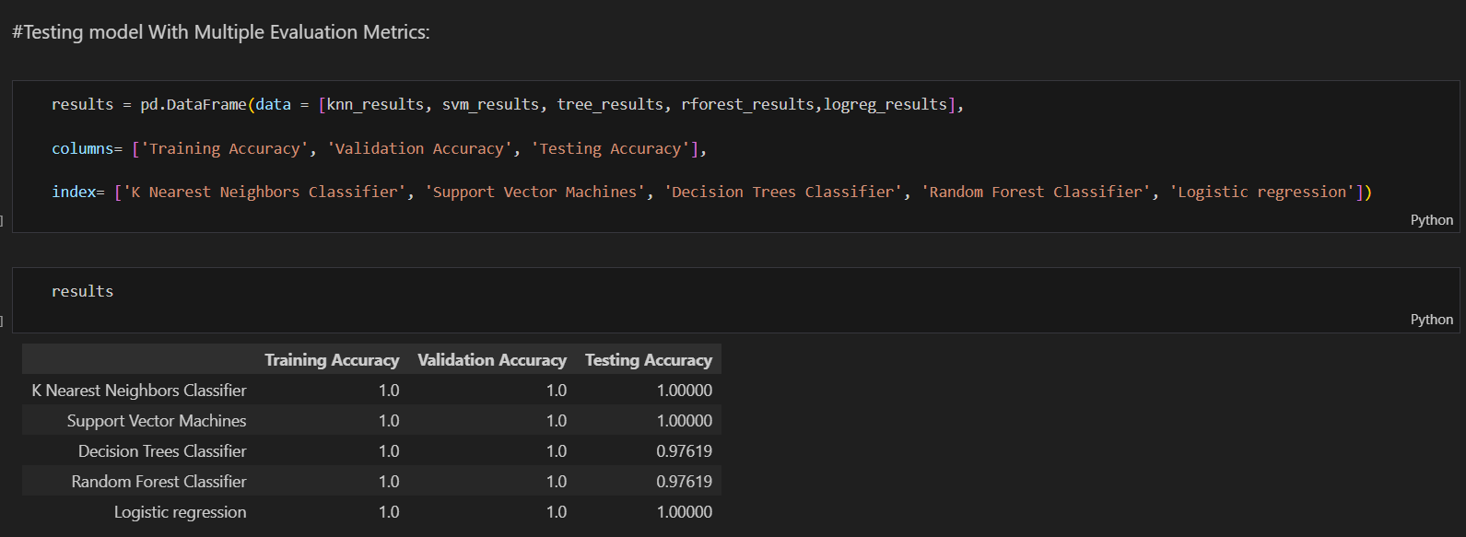

**6.2 WEB PAGES:**

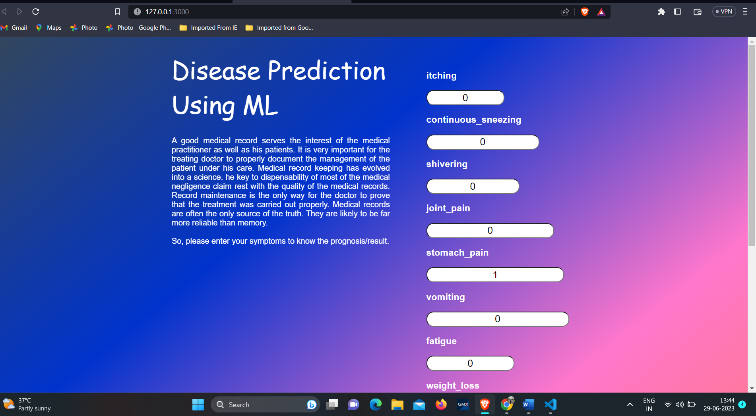

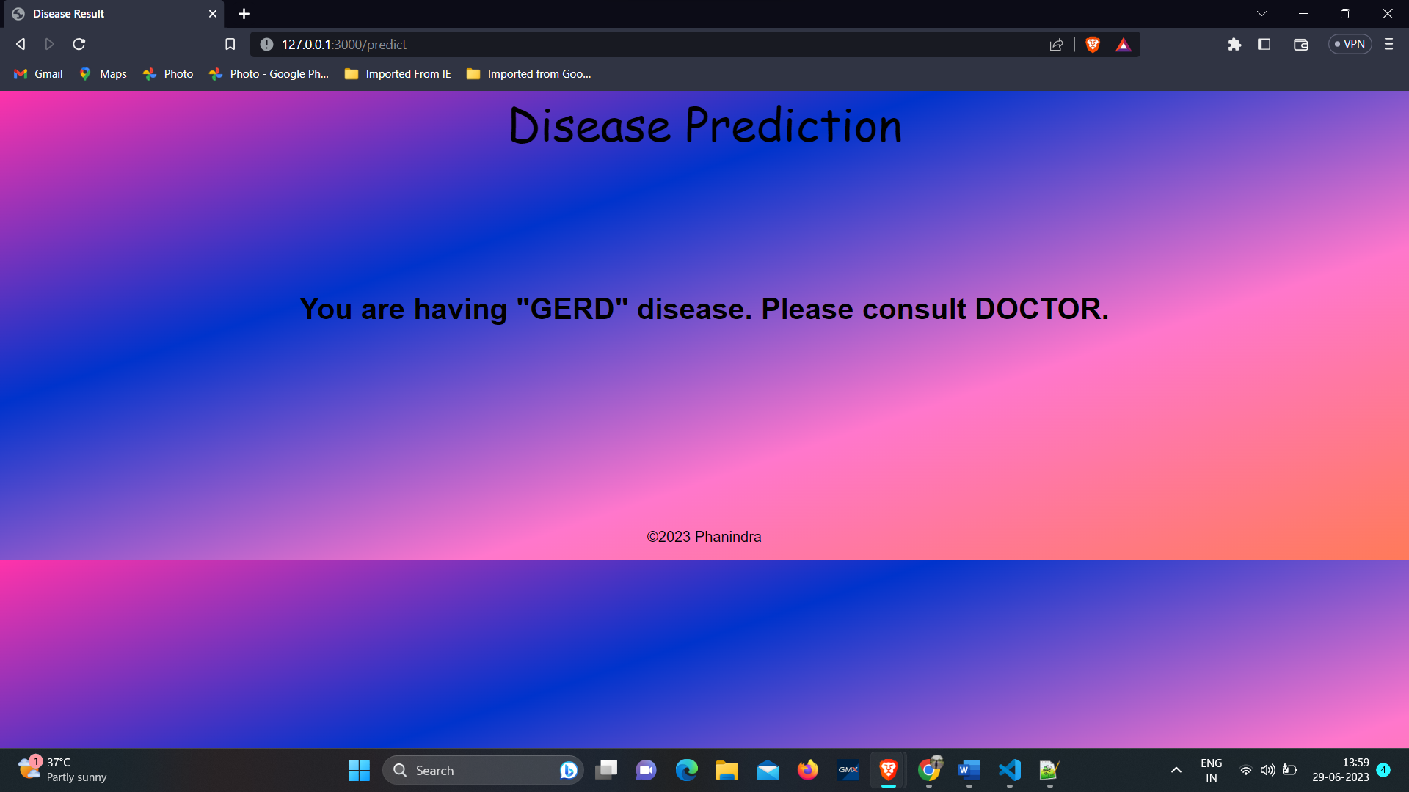

**7. ADVANTAGES & DISADVANTAGES:**

**7.1 Advantages of Disease Prediction using Machine Learning:**

1. Early Detection: Machine learning models can analyze large amounts of data and identify patterns that may indicate the early onset of a disease. This enables early detection, leading to timely intervention and improved treatment outcomes.

2. Personalized Risk Assessment: Machine learning algorithms can consider various factors such as medical history, demographics, lifestyle, and genetic information to provide personalized risk assessments. This tailored approach enhances accuracy and helps individuals make informed decisions regarding preventive measures.

3. Efficiency and Scalability: Once trained, machine learning models can process large volumes of data quickly and efficiently. This scalability allows for the analysis of vast datasets and facilitates population-level disease prediction and monitoring.

**7.2** **Disadvantages of Disease Prediction using Machine Learning:**

1. Data Limitations: The accuracy and reliability of machine learning models depend heavily on the quality and diversity of the available data. Limited or biased datasets can lead to inaccurate predictions and potential disparities in healthcare outcomes.

2. Data Privacy and Security Concerns: Disease prediction models often require access to sensitive health data, raising concerns about privacy and security. Proper data anonymization, encryption, and compliance with privacy regulations are essential to protect individuals' information.

3. Lack of Interpretability: Some machine learning models, such as deep learning algorithms, are often considered black boxes, making it challenging to understand the underlying decision-making process. Lack of interpretability can raise ethical concerns and limit the acceptance and trust in these models within the healthcare community.

It is important to acknowledge and address these advantages and disadvantages in disease prediction projects using machine learning to ensure responsible and effective implementation in healthcare settings.

**8. APPLICATIONS:**

Disease prediction using machine learning has a wide range of applications in healthcare. Some notable applications include:

1. Early Disease Detection

2. Personalized Medicine

3. Public Health Surveillance

4. Risk Assessment

5. Clinical Decision Support

6. Resource Allocation

7. Telemedicine and Remote Monitoring

These applications demonstrate the potential of disease prediction using machine learning to revolutionize healthcare by enabling early detection, personalized treatments, and improved public health interventions.

**9. Conclusion:**

Disease prediction using machine learning holds great promise in revolutionizing healthcare. The application of machine learning algorithms enables early detection of diseases, personalized risk assessments, and efficient resource allocation. By analyzing vast amounts of data, these models can identify patterns and make accurate predictions, aiding in clinical decision-making and improving patient outcomes. However, challenges such as data limitations, privacy concerns, and model interpretability need to be addressed to ensure responsible and effective implementation. Despite these challenges, the potential applications of disease prediction using machine learning are vast, offering opportunities to transform healthcare by enabling proactive interventions, personalized medicine, and improved public health surveillance. Continued research, collaboration, and ethical considerations will drive further advancements in this field.

**10. FUTURE SCOPE:**

The future scope of disease prediction using machine learning is promising. Advancements in data collection, including wearable devices and IoT technologies, will provide a wealth of real-time and continuous health data for analysis. Integration of genomics and other omics data will enhance the accuracy of predictions. Additionally, the use of deep learning algorithms and explainable AI techniques will address the interpretability challenge. Collaborative efforts, data sharing platforms, and privacy-preserving methods will facilitate the development of more robust and generalizable disease prediction models, leading to improved healthcare outcomes and personalized interventions.

**11. BIBILOGRAPHY:**

**APPENDIX:**

app.py

from flask import Flask, render_template, request

import numpy as np

import pickle

app = Flask(__name__)

model = pickle.load(open('model2.pkl', 'rb'))

@app.route('/',methods=['GET'])

def Home():

    return render_template('index.html')

@app.route("/predict", methods=['POST'])

def predict():

    if request.method == 'POST':

        itching = int(request.form['itching'])

        continuous_sneezing = int(request.form['continuous_sneezing'])

        shivering = float(request.form['shivering'])

        joint_pain = int(request.form['joint_pain'])

        stomach_pain = int(request.form['stomach_pain'])

        vomiting = int(request.form['vomiting'])

        fatigue = float(request.form['fatigue'])

        weight_loss = float(request.form['weight_loss'])

        restlessness = float(request.form['restlessness'])

        Lethargy = float(request.form['Lethargy'])

        lack_of_concentration = float(request.form['lack_of_concentration'])

        values = np.array([[itching,continuous_sneezing,shivering,joint_pain,stomach_pain,vomiting,fatigue,weight_loss,restlessness,Lethargy,lack_of_concentration]])

        prediction = model.predict(values)

        prediction=prediction[0]

        return render_template('results.html', prediction=prediction)

if __name__ == "__main__":

    app.run(port=3000,debug=True)